Hands on 4
Spring Core – Load Country from Spring Configuration XML
An airlines website is going to support booking on four countries. There will be a drop down on the home page of this website to select the respective country. It is also important to store the two-character ISO code of each country. [Text Wrapping Break]
Code | Name
US | United States
DE | Germany
IN | India
JP | Japan

Above data has to be stored in spring configuration file. Write a program to read this configuration file and display the details.
Country.java
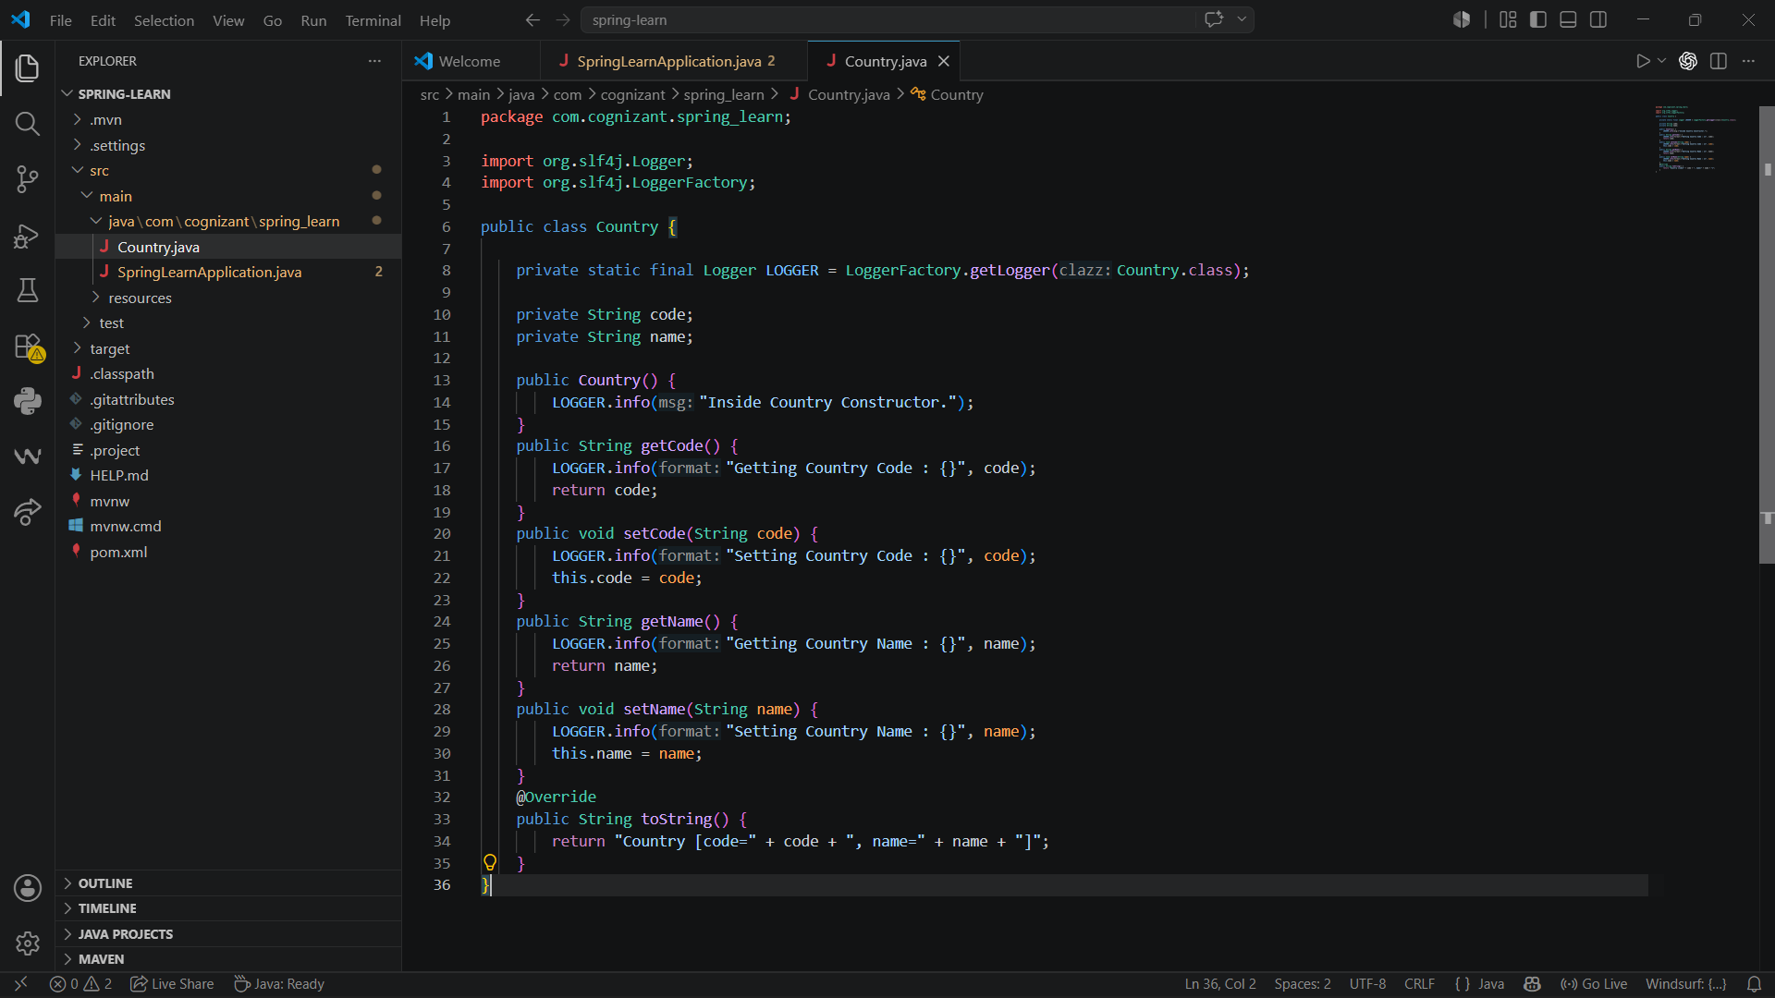

SpringLearnApplication.java
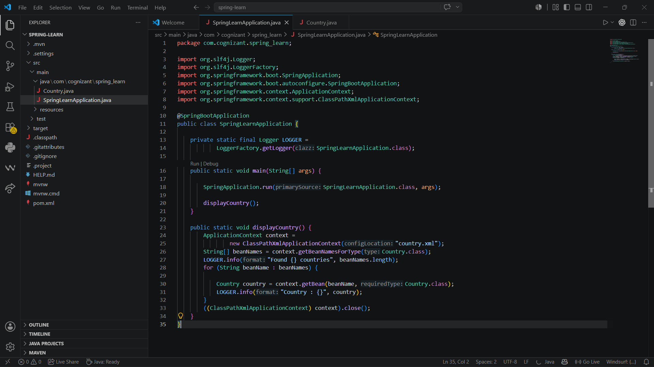
country.xml
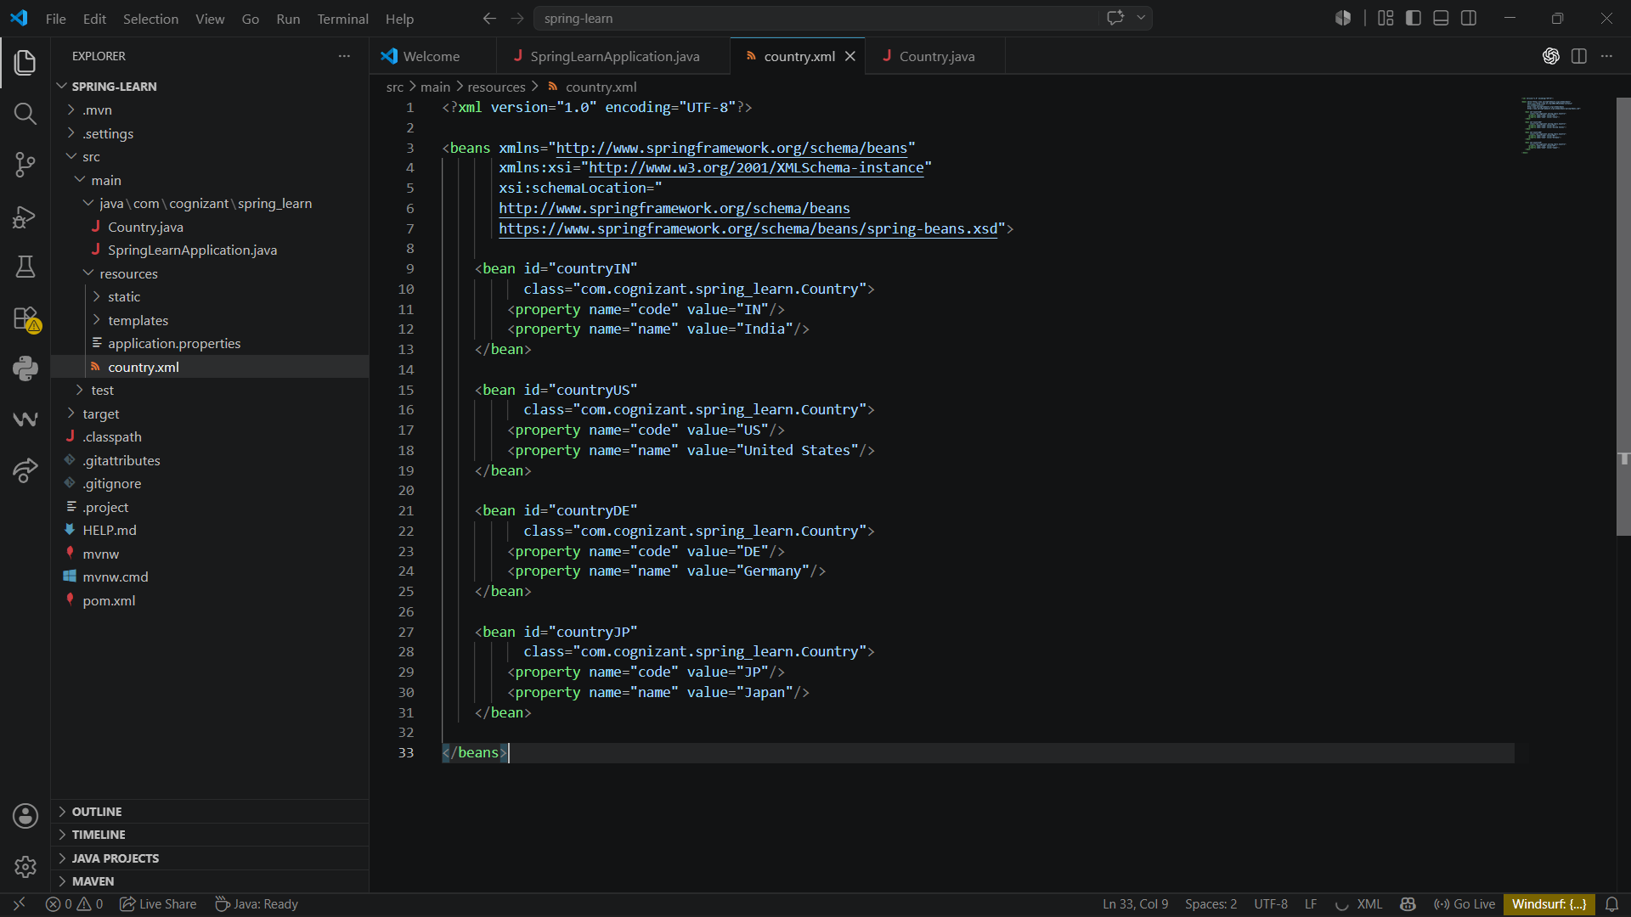

Output:
